PERIVALE PARK GOLF CLUB
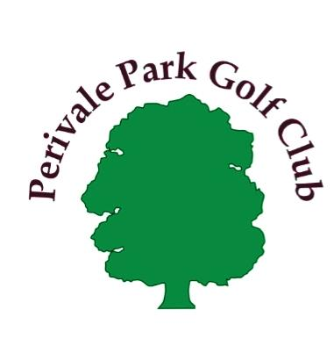
Stockdove Way, Greenford
UB6 8TJ
(020) 8575 3386

Membership application form
Please return this completed application form to Perivale Park Golf Club Pro Shop. For your information PPGC membership rates per year are - Adults £50. Seniors £30. Juniors £12. Green Fees are payable in addition. Please do not include cash. PPGC will consider your application and will contact you within a month.

Member details Please complete in block capitals
Full name | Address (including postcode)
Gender (please use M or FM)
or preferred title
Date of birth
Phone number
Mobile number
Email
(pleased provide
if you can)
Please say if you are currently a member of a golf club and your handicap if you have one

Proposed by (please sign and print)

Seconded by (please sign and print)

Can you please say how you heard of PPGC i.e. from a friend internet etc.?

I wish to become a member of Perivale Park Golf Club. If I am accepted, I agree to abide by the Rules and Constitution of the Club and the Rules of the R&A

Signature Date

FOR OFFICE USE ONLY
Decision by Committee | Applicant informed | Signature / Date
Fees Received | Signature | Date

